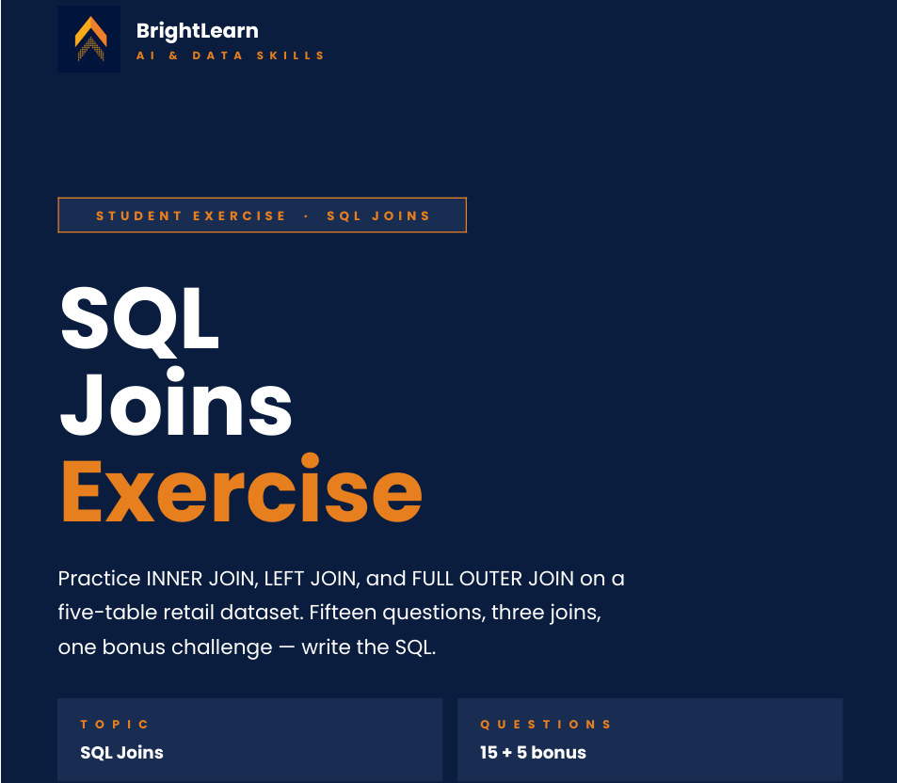

Name: Talifhani
Surname: Nemutudi
Date: 31 May 2026
APRIL DATA ANALYTICS INTAKE

INNER JOINS
Question 1
Expected columns: user_id, user_name, subscription_id, start_date
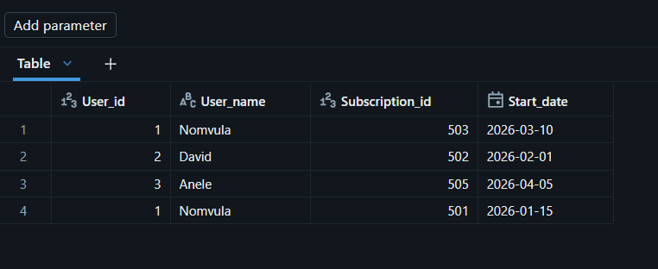

Question 2
Expected columns: subscription_id, user_id, plan_name, monthly_price
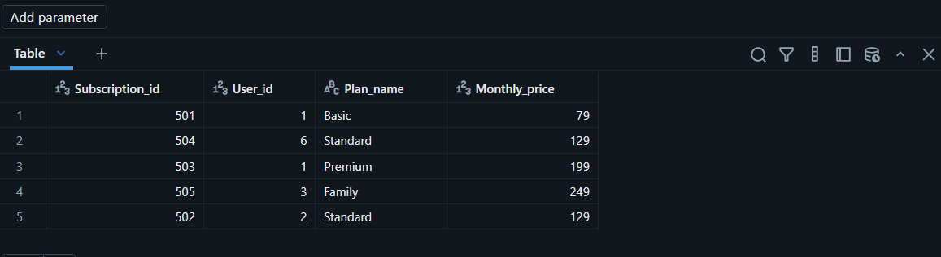
Question 3
Expected columns: session_id, user_id, show_title, genre, watch_minutes

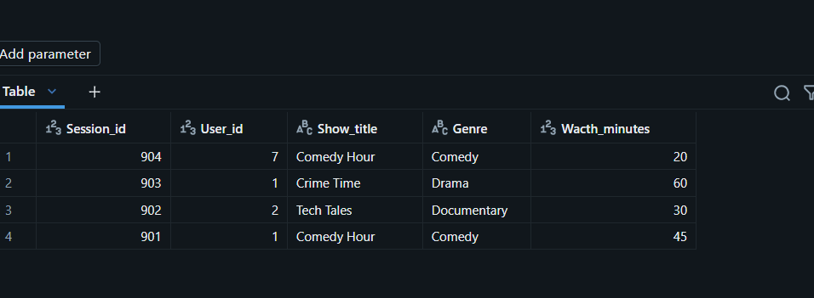
Question 4
Expected columns: user_name, country, session_id, show_id, watch_minutes
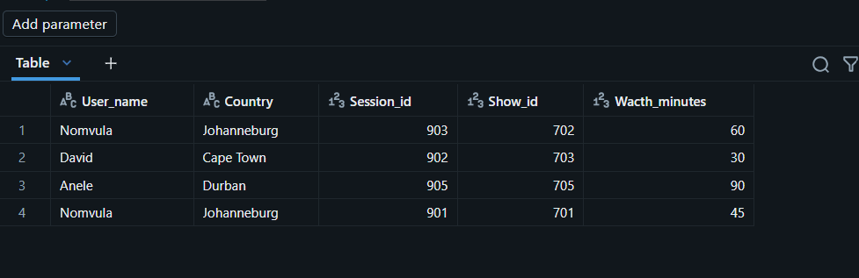

Question 5
Expected columns: user_name, country, plan_name, monthly_price, start_date
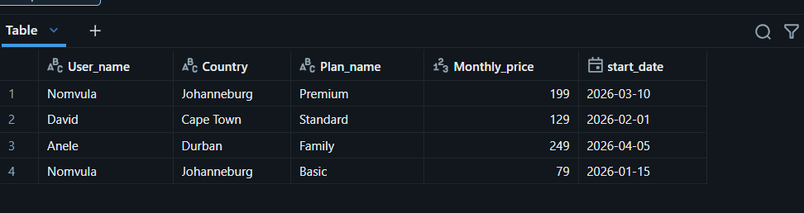

PART B LEFT JOIN
Question 6
Expected columns: user_id, user_name, subscription_id, start_date
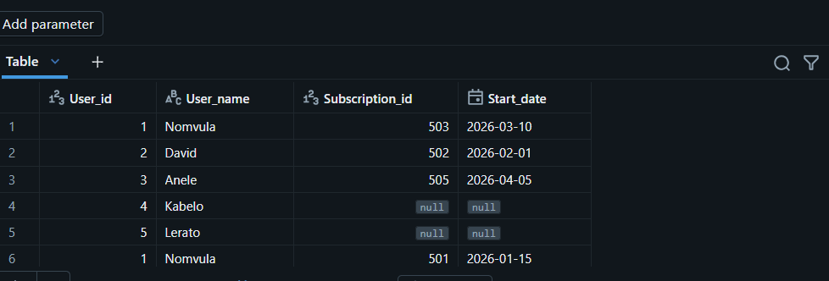
Question 7
Expected columns: plan_id, plan_name, subscription_id, user_id
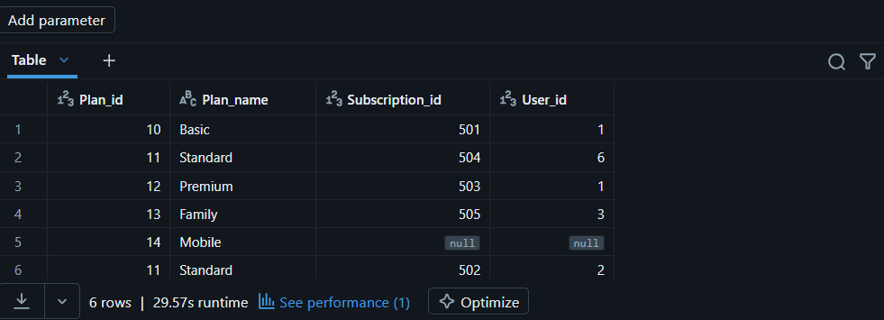

Question 8
Expected columns: show_id, show_title, session_id, watch_minutes
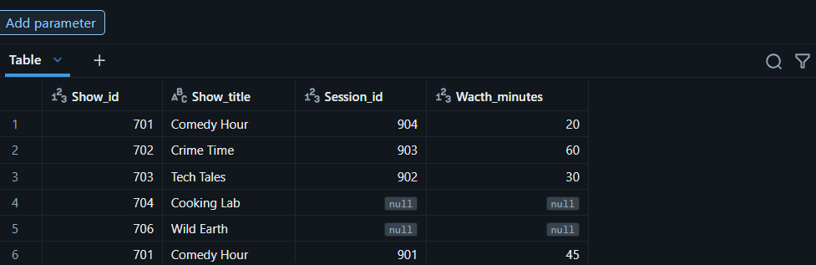
Question 9
Expected columns: session_id, show_id, watch_minutes, user_id, user_name
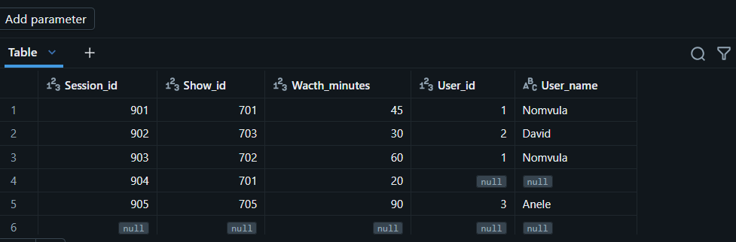

Question 10
Expected columns: user_name, country, plan_name, monthly_price
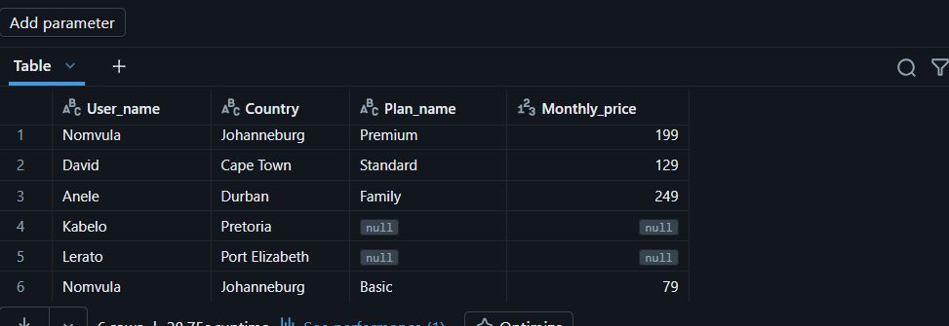

PART C FULL OUTER JOIN
Question 11
Expected columns: user_id, user_name, subscription_id, start_date
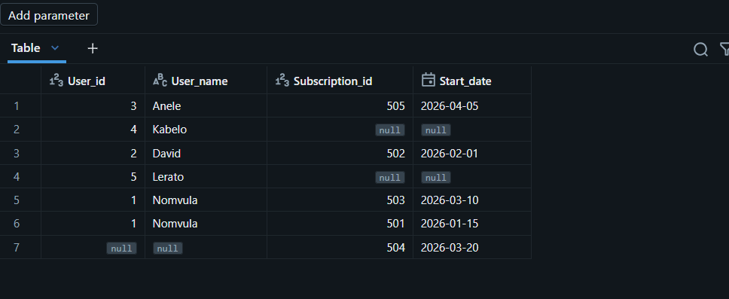
Question 12
Expected columns: plan_id, plan_name, subscription_id, user_id
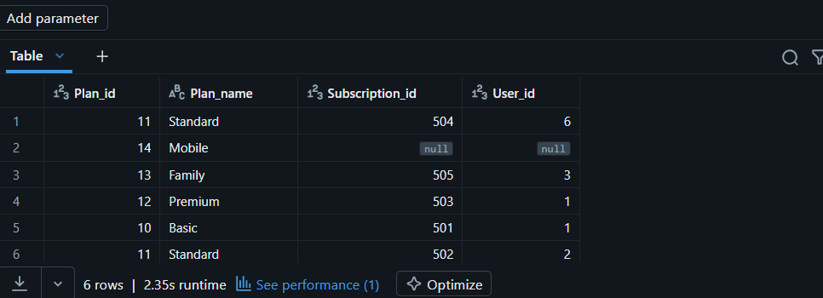

Question 13
Expected columns: show_id, show_title, session_id, watch_minutes
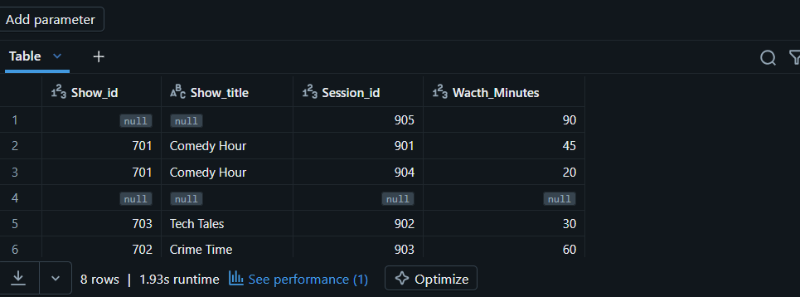

Question 14
Expected columns: user_id, user_name, session_id, show_id, watch_minutes
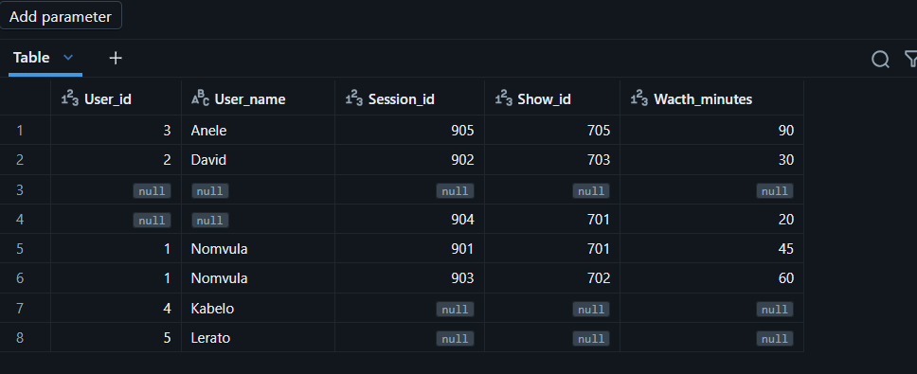
Question 15
Expected columns: user_id, user_name, subscription_id, plan_id, plan_name
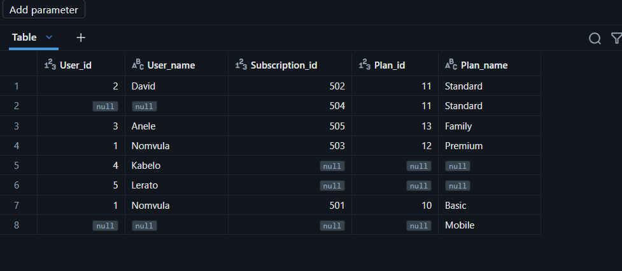

SQL ENVIRONMENT USED
This project was completed using Databricks SQL, a cloud-based data analytics platform built on Apache Spark. Databricks SQL was used to query, analyse, and aggregate data from the retail sales dataset, enabling insights into customer behaviour, revenue trends, and product performance.

